AI-Enhanced vs Legacy Digital Forensics and Investigation Tools – A Comparative Efficacy Analysis
By: Matt Baker, Sam Davies, Olivia Hey, Dave Sushames
Advisors: Dr. Bryce Antony, Clement Swarnappa Client: Geoff Gordon
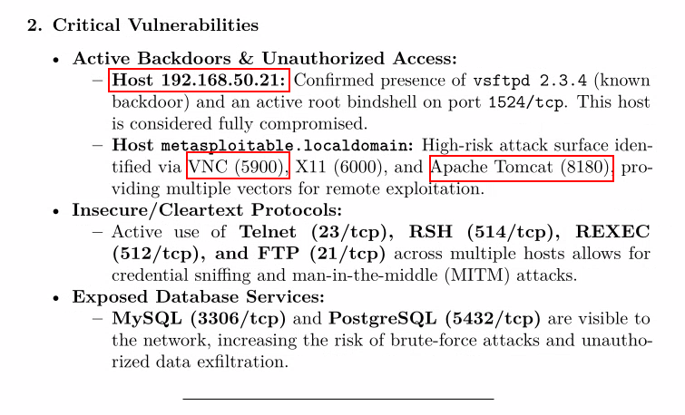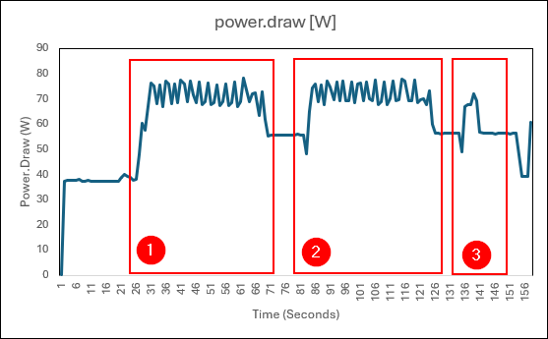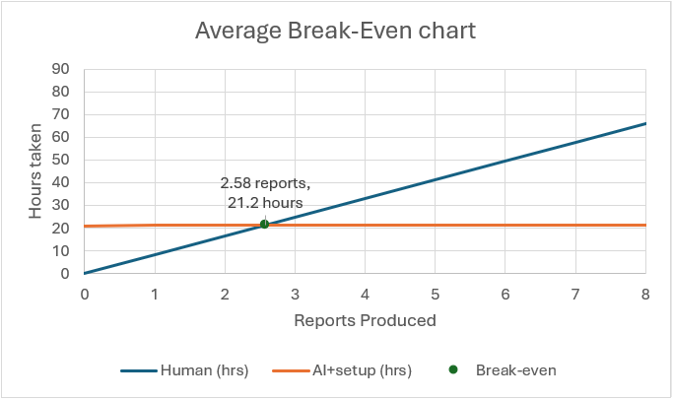

Report generated with thinking enabled GPU Power draw during script execution Human – LLM break-even chart

INTRODUCTION
Digital forensic investigators spend hours turning forensic tool outputs into readable reports. Large Language Models (LLMs) could reduce the amount of time in producing a report, but forensic work requires accuracy, repeatability, and a chain of custody.
This project investigates the performance and quality of digital forensic reports delivered by a locally hosted LLM compared to those completed by human analysts when both are aided by three traditional forensics tools. The tools chosen for this project were Foremost, Wireshark and Nmap.
DEVELOPMENT
The project used the Design Science Research methodology as the project’s framework while the testing approach was inspired by the structured, repeatable, and evidence-based NIST Computer Forensics Tool Testing program (CFTT). The methodology was adapted to compare human and LLM reports, instead of tool behaviour.
The test environment was a Kali Linux machine running Ollama. The model used was Gemma4:26b with customized parameters, such as setting the temperature to 0 and a set seed for reproducibility.
A Python automation script was built for each of the three tools to produce a report on their outputs. NinemostV1 handles Foremost, SilentCartographerV1 handles Nmap, and HammerheadV1 handles Wireshark. A total of 18 reports were made, with humans and LLM both producing three reports per tool.

The main challenge we encountered was fitting forensic data into the model’s context window. We increased the context window to 32k tokens, disabled thinking to save on output space, and split large inputs into multiple chunks that could be processed one at a time. Converting files to an LLM friendly format also helped cut context usage. A Wireshark .pcap file converted to .csv cut the size from 335 KB to 56 KB.
Chunking the file, while helping reduce context usage, revealed a trade-off. With thinking disabled, splitting an Nmap scan caused the model to attribute services to the wrong hosts. With thinking enabled, it was able to reassemble the chunks correctly, so it is recommended to enable thinking whenever chunking is used.
However, the speed and setup time of LLMs are an important factor. LLM reports took an average time of 51 seconds to produce compared with human reports which took a mean time of 21.23 hours. While they are able to create reports at a faster rate than human investigators, each script required an average time of 21 hours for development. This upfront cost relatively reduces the total advantage that they bring.
CONCLUSION
LLMs provide a large speed advantage in DFIR reporting, but our tests show that their reports were less detailed than those produced by humans. They also have trouble analysing larger datasets and sometimes produce inaccurate details. They are best used to make a first pass, highlighting data of interest for the human analyst to investigate further.

